5 Easy Ways to Detox the Body and the Mind!

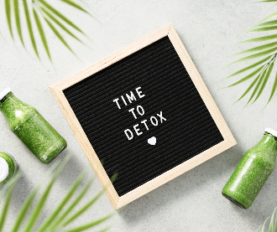
January is the month where we put so much pressure on ourselves to become this perfect person. Like how can we change everything so drastically within a few days?

Last year I wrote my January blog on setting goals not new year’s resolutions, which personally I like to write or at least start thinking about a few days before the new year actually begins. I like to be prepared.

I think for most of us, December becomes this crazy, busy time of year where normal life briefly disappears and so does our routine of looking after ourselves both physically and mentally.

The first week that the kids are back to school, you’re back to back to normal life in general goes so quickly it’s ok to let this week pass. The second week however I am ready for the new year to begin. Yes, I am aware this brings us to the 9th of January (the day I am writing this) but that’s ok. I have got everything else around me straight which is what I need before I can start focusing on me.

For me this includes detoxing from the past month, well ok the past 6 weeks or so.
Detox my body and my mind!

My Detox Tip One – Exercising

I love exercising! Yes, call me strange, I am aware that I am. Being a massage therapist I must ensure I keep physically fit and strong but also it keeps my mental health well. When I go through periods of time when I can’t exercise for whatever reason I really notice my mood drop.

Exercise can mean different things for everyone. My exercise ranges from intense cardio, weights, yoga to simply walking my dog. All of these give me huge but a variety of benefits. The most important thing for you to do is finding something that you enjoy so you don’t dread it, keeping your body moving and healthy.
Try and aim to do any combination of exercise 3-5 times a week.

My Detox Tip Two – Vitamins

There is nothing about Christmas that screams healthy!!!
I am a sucker for chocolate, alcohol, cheese, chocolate log etc. I do allow myself to indulge in these over Christmas however I cannot sustain this all year, my waistline and my skin would not be happy.
Feeding your body with vitamins will make your body so happy as well as feeding your skin making it healthy, glowing and more youthful.
I can hand on heart say I feel physically and mentally so much happier and healthier when I eat plenty of fruit and vegetables.
Try to consume 5 portions of fruit or vegetables a day.

My Detox Tip Three – Exfoliate

You may think is a strange one but again during the festive period even I don’t get round to exfoliating both my face and body which is ridiculous because it literally takes a couple of minutes.
When I don’t exfoliate, I literally feel like my skin is clogged up of all the toxins I have consumed, and I need to get it off my skin.
Honestly try it! 1-2 times a week is plenty, you will see a nice healthy glow of happy skin.

My Detox Tip Four – Drink Water!

You must know me by know. Our bodies need this to keep our joints, organs, muscles and skin healthy and working well! Alcohol dehydrates our bodies leaving not much to flush out the toxins through and out within the body. Increase your intake of water week by week. Doing this slowly will help to drink more naturally in the future, you can’t go from 1 glass to 2 litres overnight. Set realistic goals. No one is perfect and we will have plenty of days when we don’t drink the recommended 2 litres of water, but that’s ok, there is always the next day to try!

My Detox Tip Five – Meditate

Firstly, mediation doesn’t have to be hard, long, boring or even something you do daily. I actually don’t get round to mediating as often as I would like. If I could manage once a week, I would be a very happy girl!
I love to listen to guided meditations which I find on you tube. Trust me I from far perfect, I need to listen to guided mediations because left to my own devices my mind wonders everywhere!

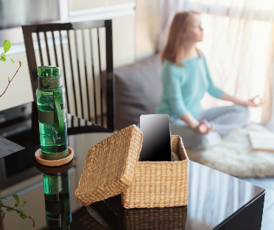
I find mediating grounds me and I can reconnect to myself.

To help to reconnect to the world I do like to walk in the fields, with nature.

Just do something where you can take yourself away from the day to day crap of life and the world!

Don’t try and do all of five of these at once. Pick one you like the most and when you have cracked one, add a second, and so on.

Happ New Year!
Rachel x

